Maslow’s Hierarchy of Needs shows that there are basic human needs that must be met before an individual can progress to fill the next order need. At the bottom of the pyramid are the deficit needs, which, Maslow noted, increase in strength the longer they remain unfulfilled. Physiological needs, such as food, and clothing and shelter, are at the foundation of the hierarchy and must be fulfilled before moving to the being needs, which consist of the acquisition of knowledge and aesthetic appreciation, such as art, music, and beauty. Maslow’s ultimate goal for a human is self-actualization. Self-actualized people are rare, as they have all their needs met; these people can now move on to helping others become self-actualized. Our video shows the journey of one man as he seeks to fulfill each of Maslow’s specified needs.

https://www.youtube.com/watch?v=ZEsaF6uLBe0

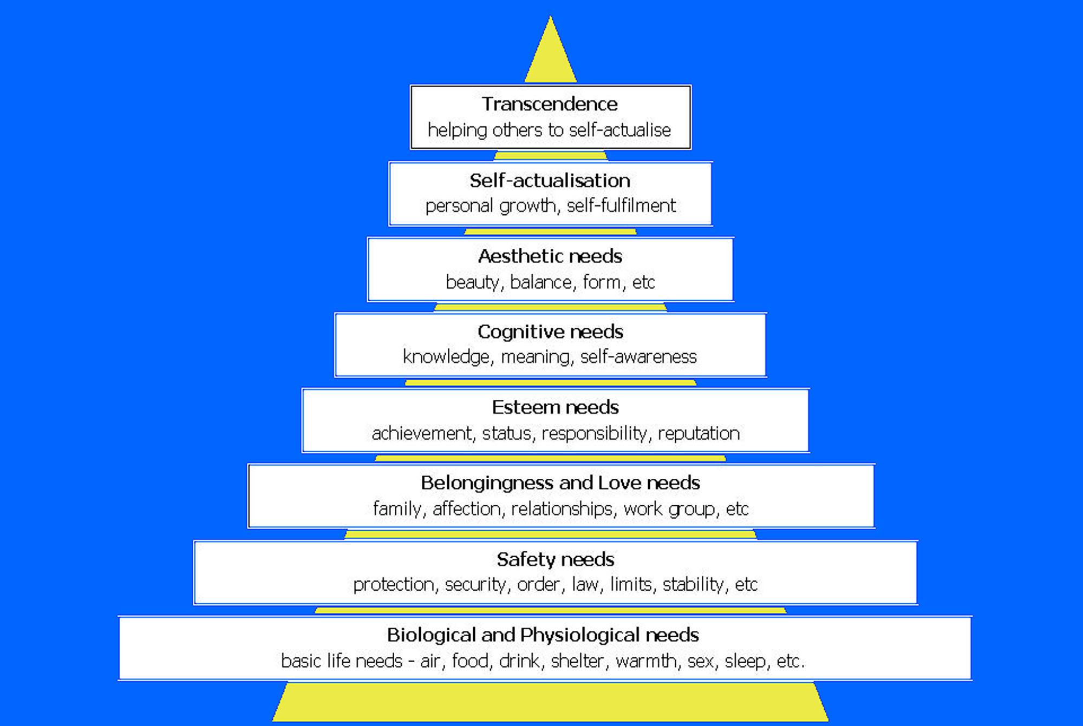

https://www.google.com/url?sa=i&rct=j&q=&esrc=s&source=images&cd=&cad=rja&uact=8&ved=0CAcQjRxqFQoTCOXo6Jzx78YCFck4iAodSAYCRA&url=https%3A%2F%2Fwikispaces.psu.edu%2Fdisplay%2Fpsych484%2F2.%2Bneed%2Btheories&ei=PyawVaXNDcnxoATIjIigBA&bvm=bv.98476267,d.cGU&psig=AFQjCNGjWwQ1mhleOruex4-9pAfpsY5_cA&ust=1437693765412019

